

**GAMING ARTICLE WEBSITE**

Group 3

Written by :

Fikhri Maheswara Taswandi

Layalia Hasya

Faculty :

**MR. REZA MAULANA, S.kom, M.kom**

Class :

3WD1

**CEP CCIT**

**FAKULTAS TEKNIK UNIVERSITAS INDONESIA**

**2023**

**PROJECT ON**

*Gaming Article website*

**Developed by**

1. **Fikhri Maheswara Taswandi**
2. **Layalia Hasya**



**Gaming Article website**

Batch Code : 3WD1

Start Date : 29h December 2024   
End Date : 2nd January 2025

Name of Faculty : MR. REZA MAULANA, S.kom, M.kom

Names of Developer :

1. Fikhri Maheswara Taswandi
2. Layalia Hasya

Date of Submission: 2nd January 2025

**CERTIFICATE**

This is to certify that this report titled “Gaming Article Website” embodies the original work done by Fikhri Maheswara Taswandi and Layalia Hasya. Project in partial fulfillment of their course requirement at NIIT.

Coordinator:

MR. REZA MAULANA, S.kom, M.kom



**ACKNOWLEDGEMENT**

**SYSTEM ANALYSIS**

**System Summary:** For project 1 in semester 2, we initiated to create an online flight ticket booking program using the Java programming language. This program is often used and needed by tour and travel agents. The program we created is not only for booking flight tickets, but can also be used to view the number of tickets sold, ticket buyer data along with financial reports that can be accessed by the Manager. In conclusion, by using the Java programming language, a flight ticket booking system can be created easily and efficiently. This system provides a more comfortable experience for both reception staff and managers in managing orders and transactions made.

Thank you, the writers wish to Allah SWT, the Almighty God for His blessings and mercy, that we can complete this Project 3 task, both in the form of paper and in the form of presentations in a timely manner.

Thank you especially for faculty, MR. REZA MAULANA, and other faculty who always help. Thank you to the fellow friends who have supported, and also thank you for being a partner in this education at CCIT-FTUI.

Project 3 paper entitled “Gaming Article Website” which we proposed as a requirement for the Project 3 assignment.

We realize that in the preparation and writing, there are still many mistakes. Therefore, we apologize for the errors and imperfections that readers find in this paper. We also hope for criticism and suggestions from readers if they find errors in this paper.

Finally, we hope that this paper that we have compiled can add insight to readers in general and writers in particular. Hopefully, this report can be useful for other writers and for the readers.

**SYSTEM ANALYSIS**

Websites are widely used by people today for various reasons. It could be access to information.Websites provide easy access to information on a wide range of topics, from news and education to entertainment and shopping. Convenience. People can shop online, pay bills, book tickets, and perform many other tasks from the comfort of their homes.

Communication. Websites facilitate communication through email, social media platforms, and forums, connecting people from all over the world. Entertainment. People use websites to stream videos, listen to music, play games, and read articles for entertainment. Learning and Education. Educational websites offer courses, tutorials, and resources to learn new skills and gain knowledge.

Social interactions and social media websites allow people to stay connected with friends and family, share news, and meet new people. Business and Work. Websites are essential for remote work, online meetings, collaboration, and conducting business transactions. Health and Wellness. Health websites provide information about medical conditions, fitness tips, and health services.

Shopping or e-commerce websites allow people to purchase products and services online, often with a wider selection and at cheaper prices than in physical stores. Banking and finance, or online banking websites, allow people to manage their finances, pay bills, and make transactions easily and securely.

Overall, websites are used because they offer convenience, access to information, communication, and various services that make everyday tasks easier and more efficient.

**Scripting Language :** PHP Native

**Database :** MySQL

**Web Server :** XAMPP (phpMyAdmin)

**TECHNOLOGY**

|  |  |  |  |
| --- | --- | --- | --- |
| NO | NAME | DESCRIPTION | DATE |
| 1 | Layalia Hasya | Design concept | December 28, 2024 |
| 2. | Fikhri Maheswara | Create FrontEnd | December 31, 2024 |
| 3. | Fikri Maheswara | Create BackEnd | January 1, 2025 |
| 4. | Layalia Hasya | Ms.word and Power Point | January 2, 2025 |
| 5. | Fikri Maheswara | Finishing | January 2, 2025 |

**ACTIVITY LIST**

Database Design : gaming_corner

**Number of Table** : 4

**Table List**  :

* Users
* Authorrequest
* Article
* Categories

Coordinator:

Mr. Reza Maulana, S.Kom., M.Kom.

**DATABASE DESIGN**

A schematic diagram is a visual representation of the relationships and source code dependencies among classes in the Unified Modeling Language (UML).

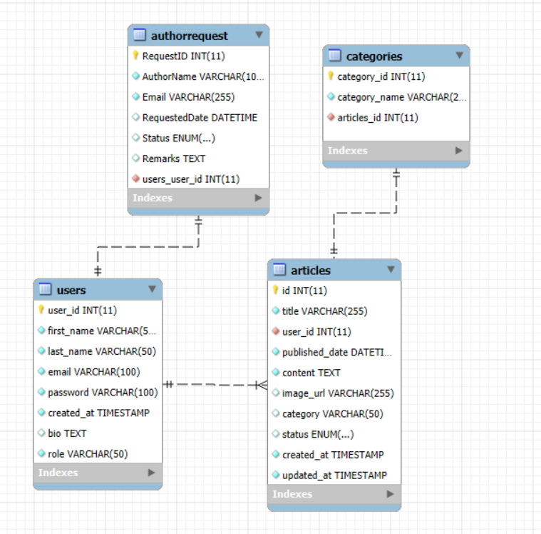

**SCHEMATIC DIAGRAM**

**DATABASE TABLE**

The table design of online gaming article is as follows:

users

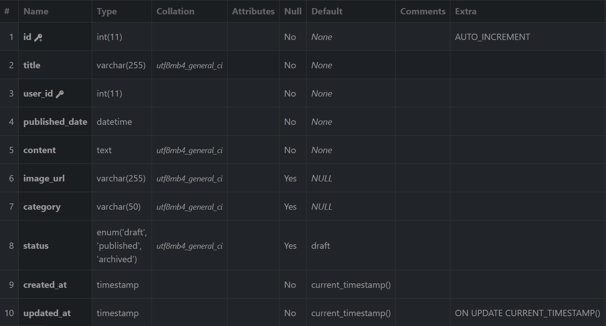

Authorrequest

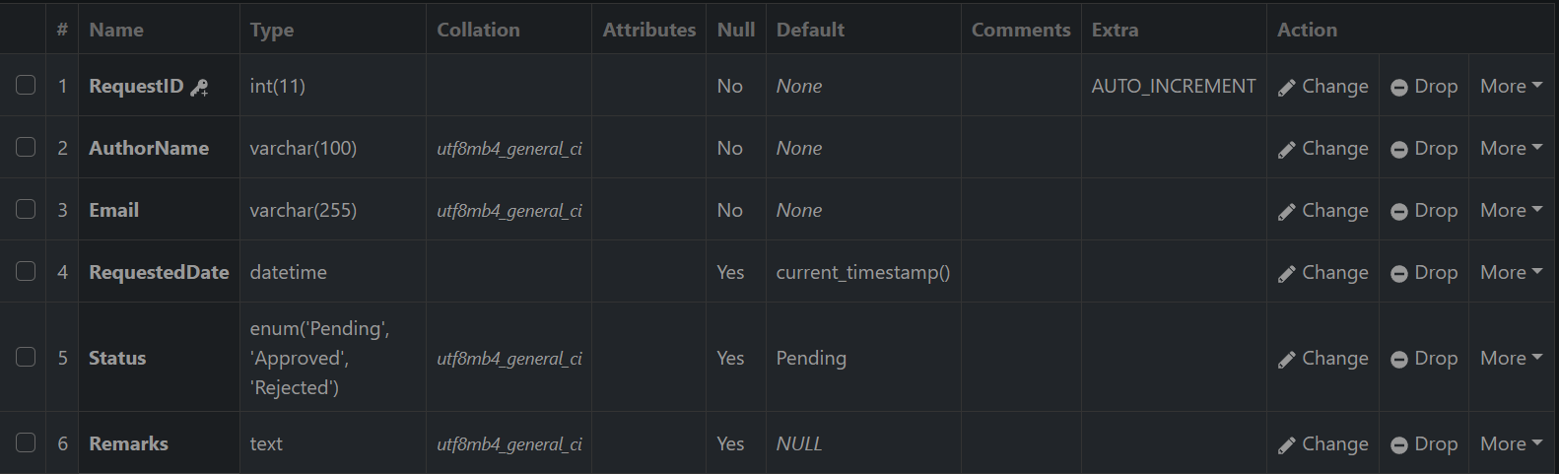

**DATABASE TABLE**

articles



Categories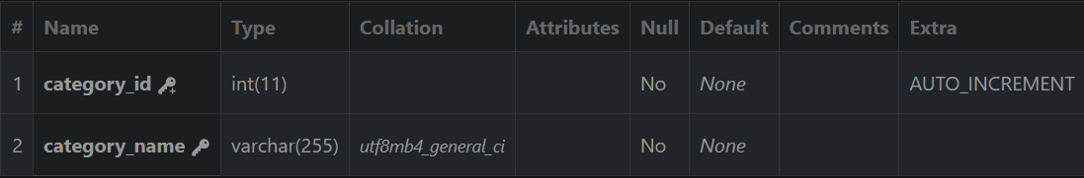

**PREVIEW OF ARTICLE**

**HOME PAGE MOBILE**



**PREVIEW OF WEBSITE**

**HOME PAGE MOBILE EXTENDED**

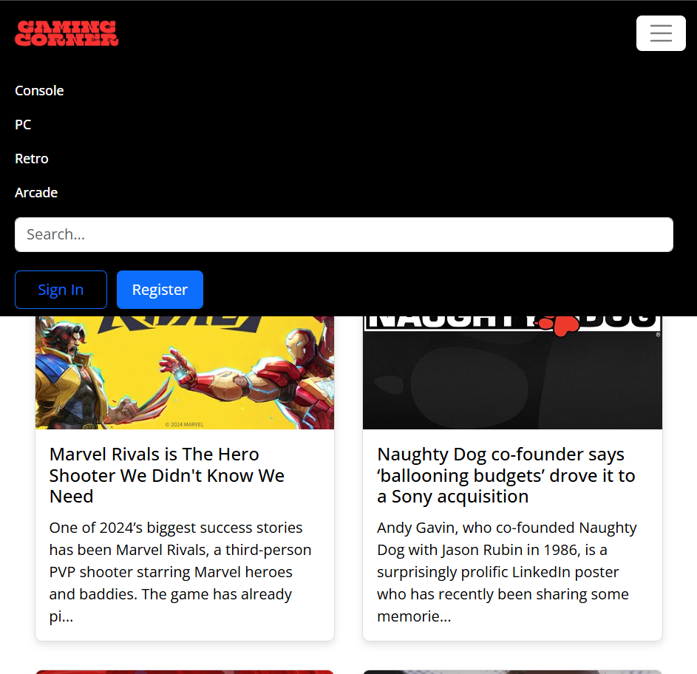

**PREVIEW OF WEBSITE**

**HOME PAGE**



**CATEGORY PAGE**

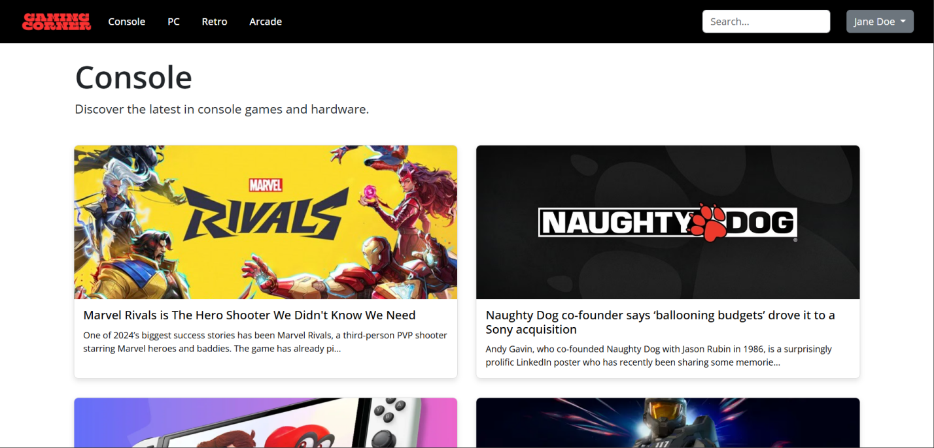

**PREVIEW OF WEBSTIE**

**ARTICLE CONTENT PAGE**

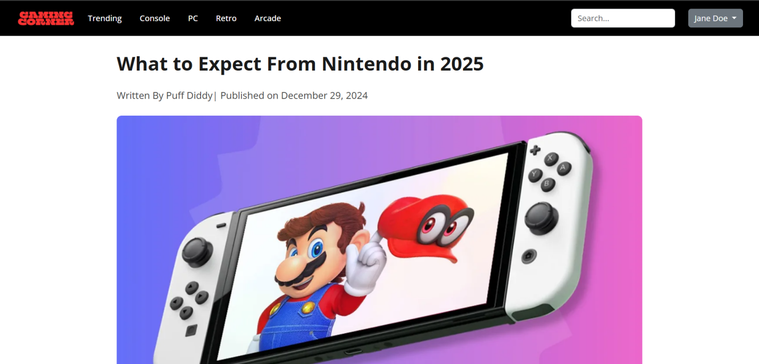

**ARTICLE CONTENT PAGE (2)**

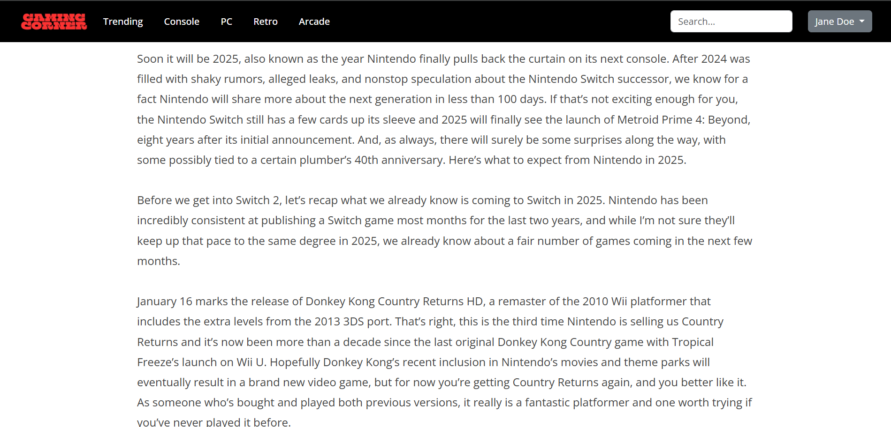

**PREVIEW OF WEBSTIE**

**ARTICLE CONTENT PAGE RELATED ARTICLE**

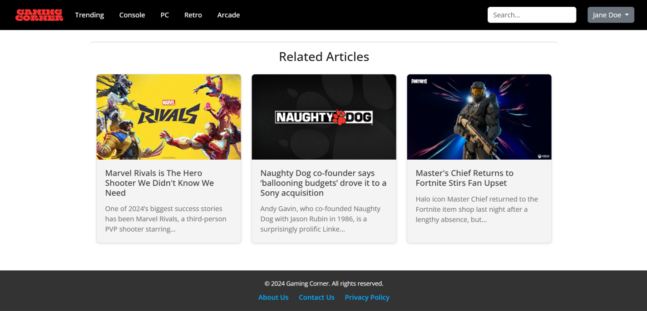

**PROFILE PAGE**

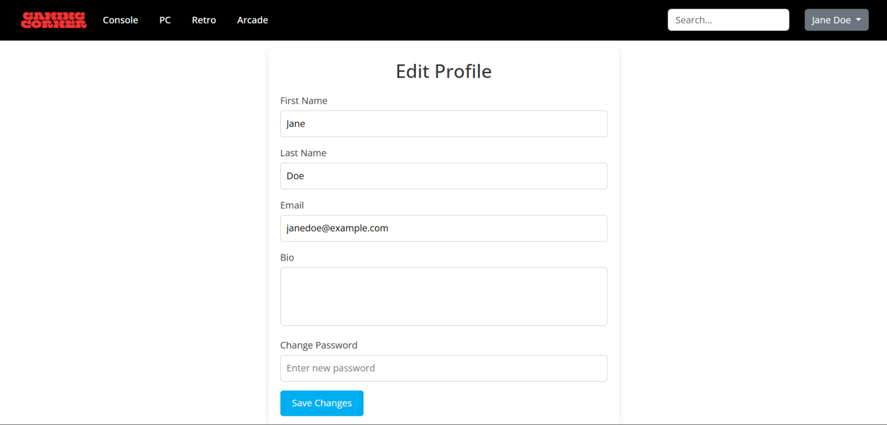

**PREVIEW OF WEBSTIE**

**REGISTER PAGE**

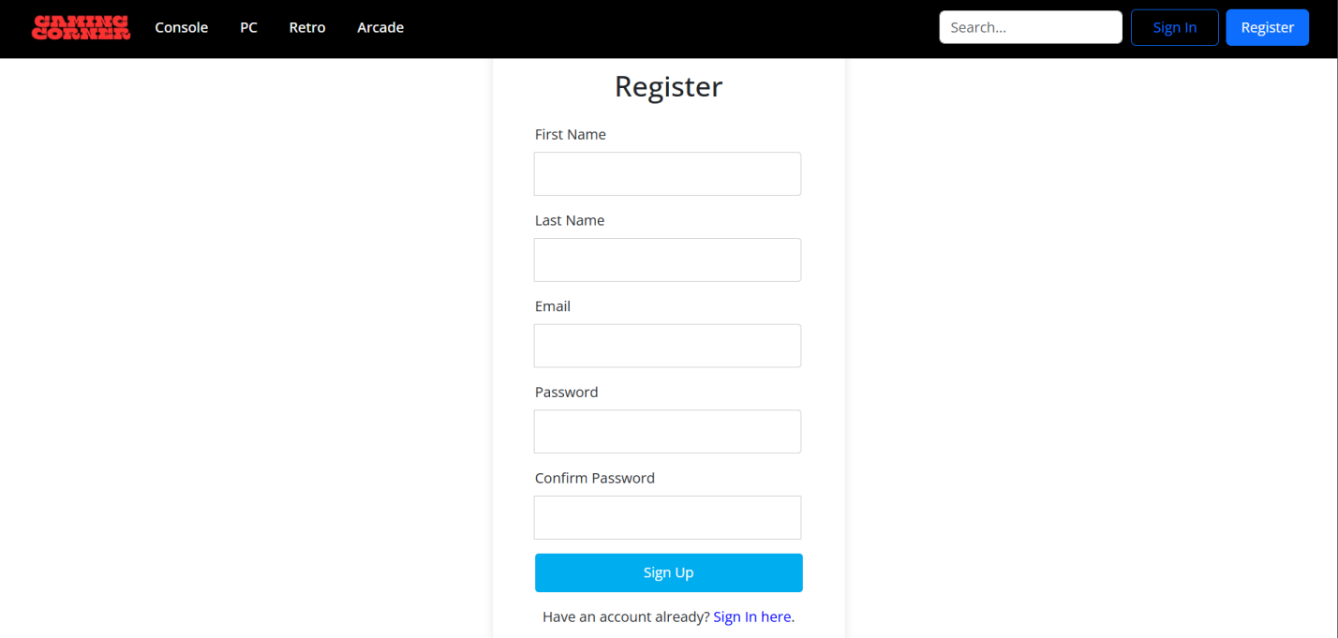

**AFTER REGISTER**

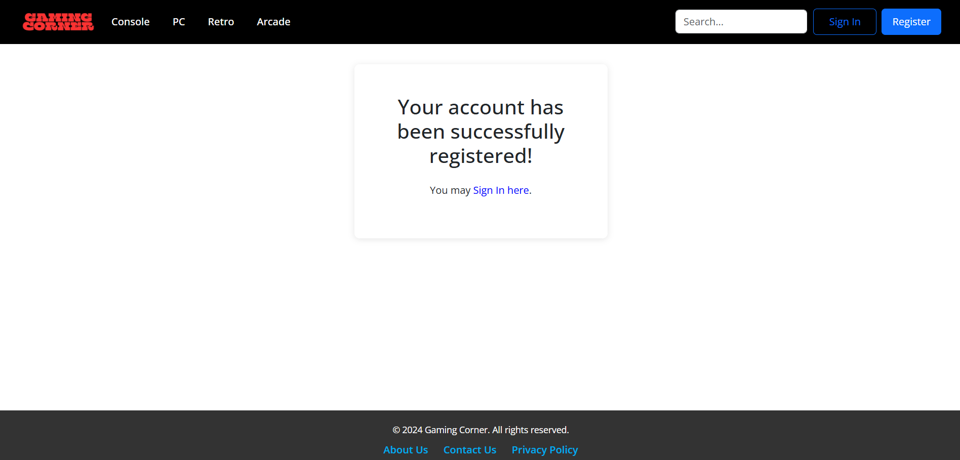

**PREVIEW OF WEBSTIE**

**SIGN IN PAGE**

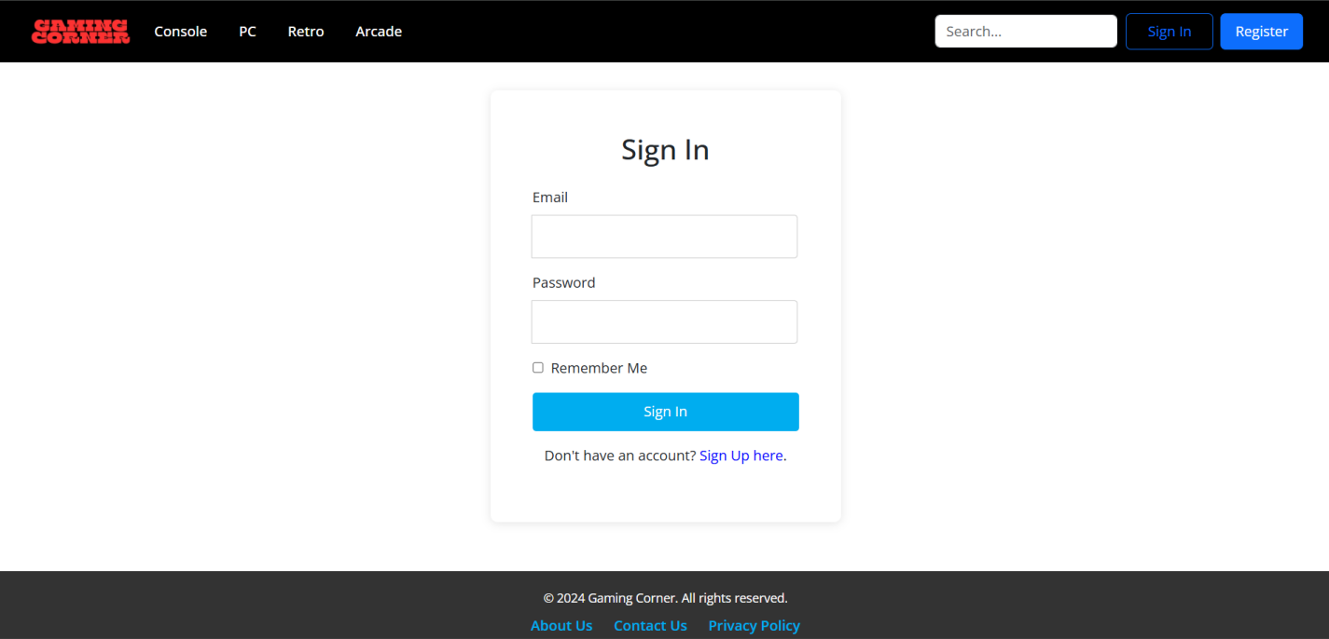

**PROFILE WHO WRITE ARTICLE**

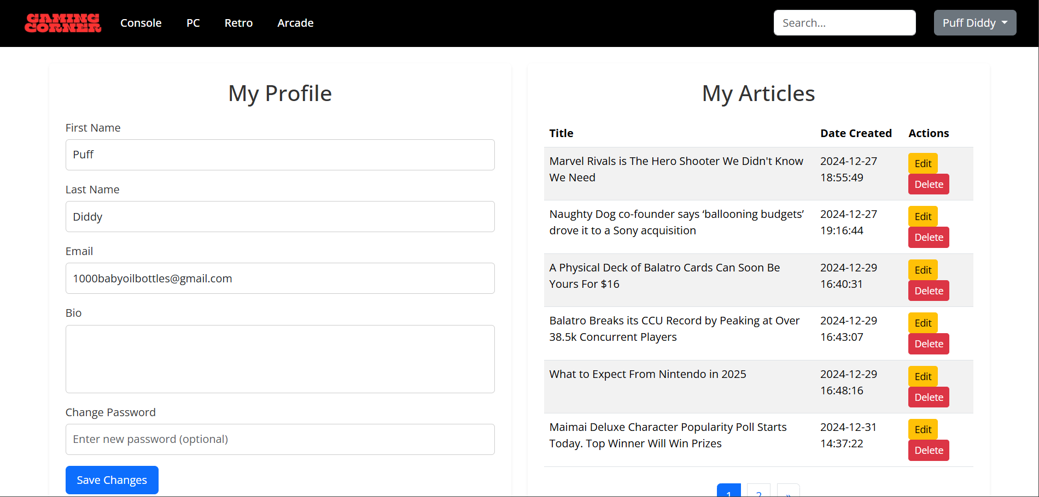

**PREVIEW OF WEBSTIE**

**PROFILE WHO HASN’T WRITE ANY ARTICLE**

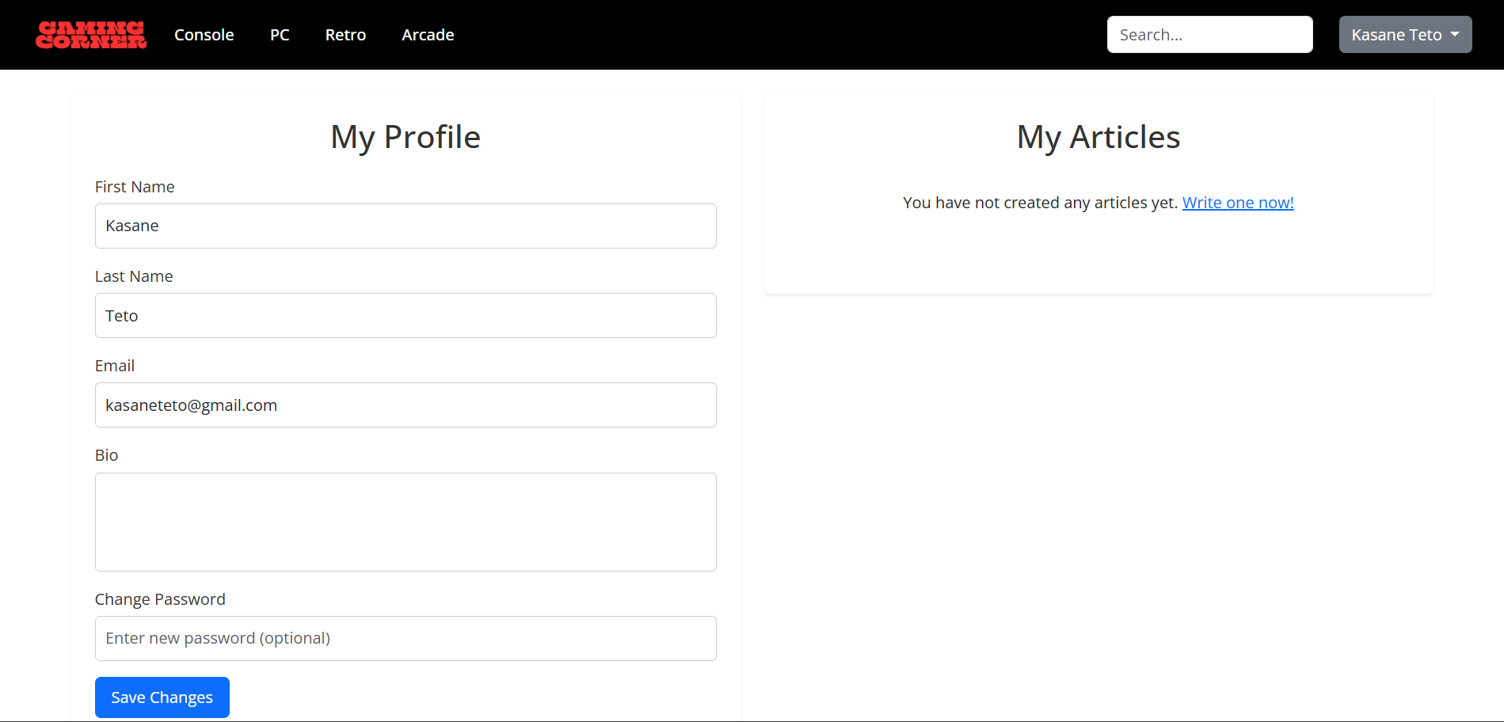

**EDITING ARTICLE PAGE**

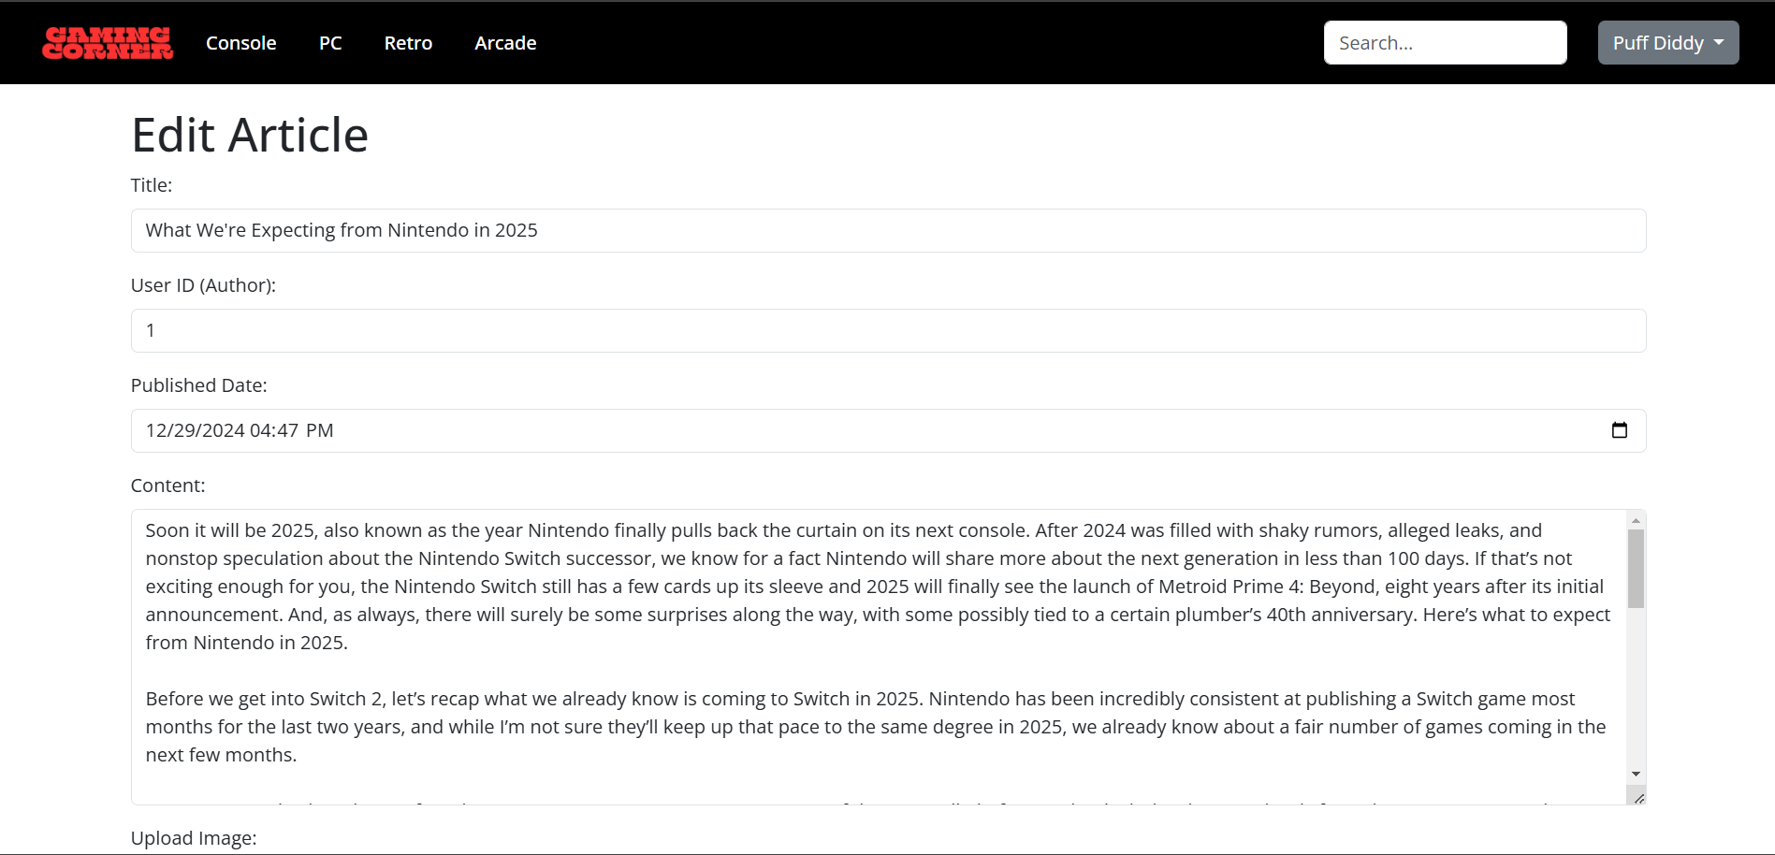

**PAGE UI ADMIN**

**PAGE UI ADMIN**

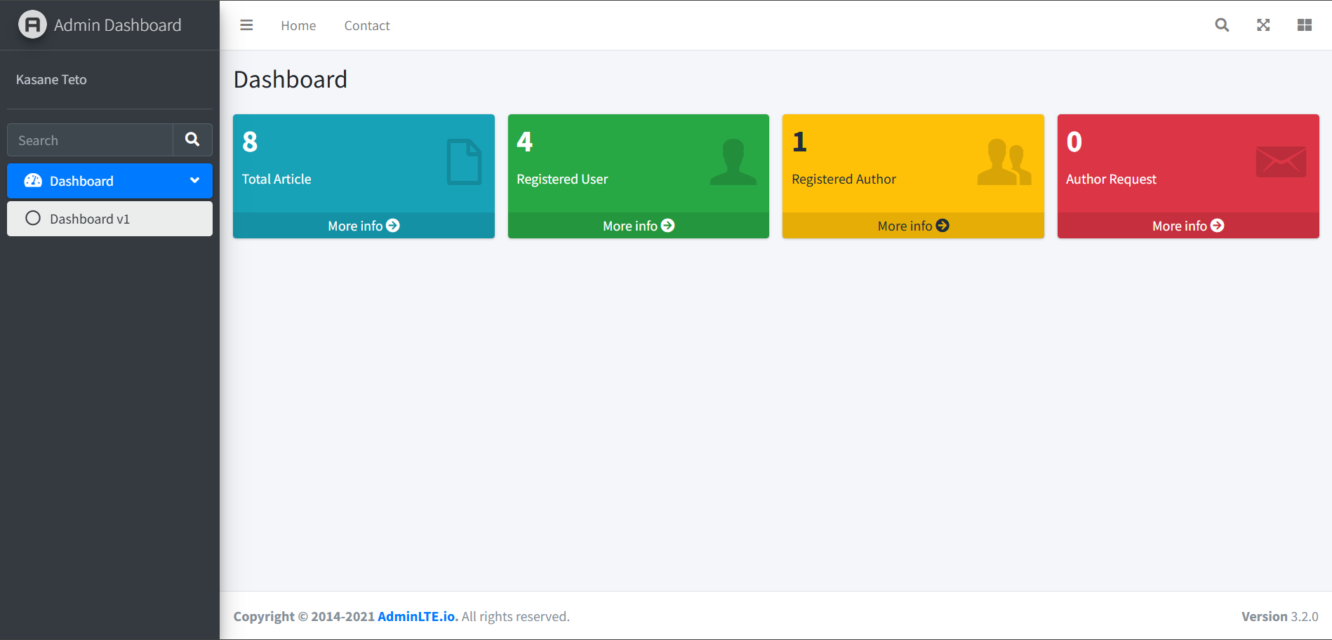

**TOTAL ARTICLE**

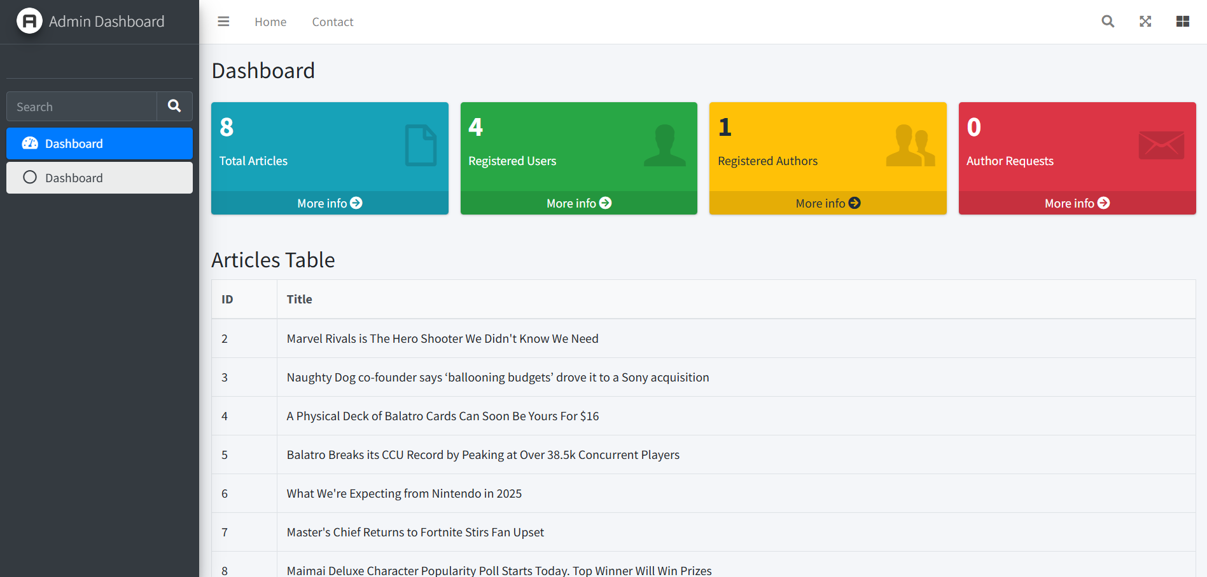

**PAGE UI ADMIN**

**REGISTERED USERS**

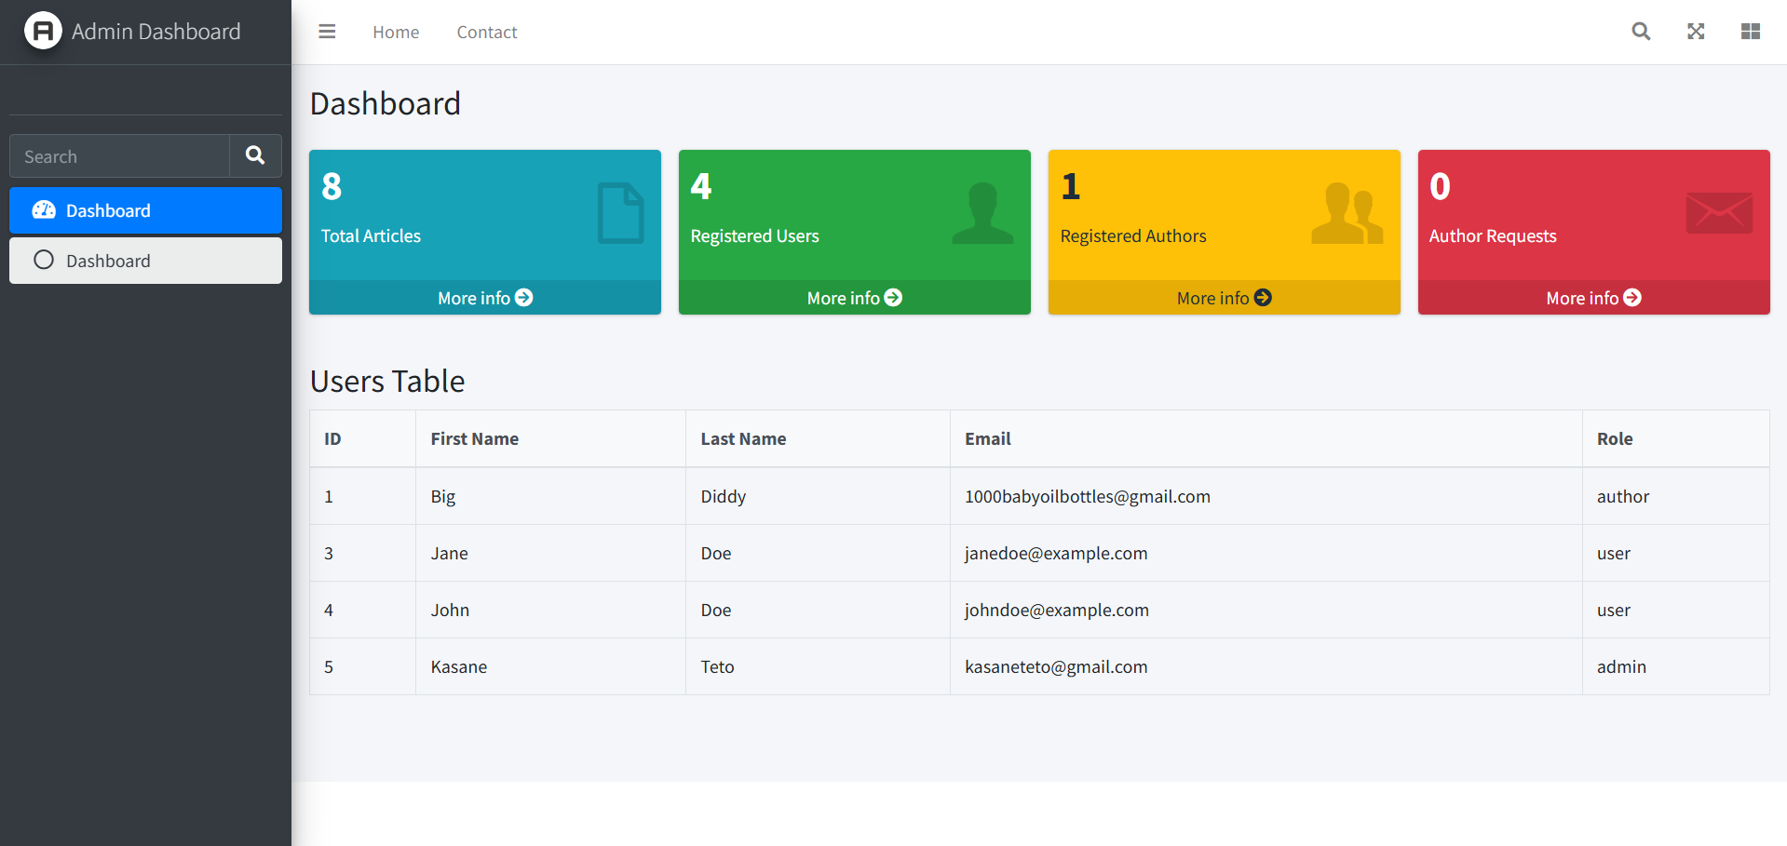

**REGISTERED AUTHORS**

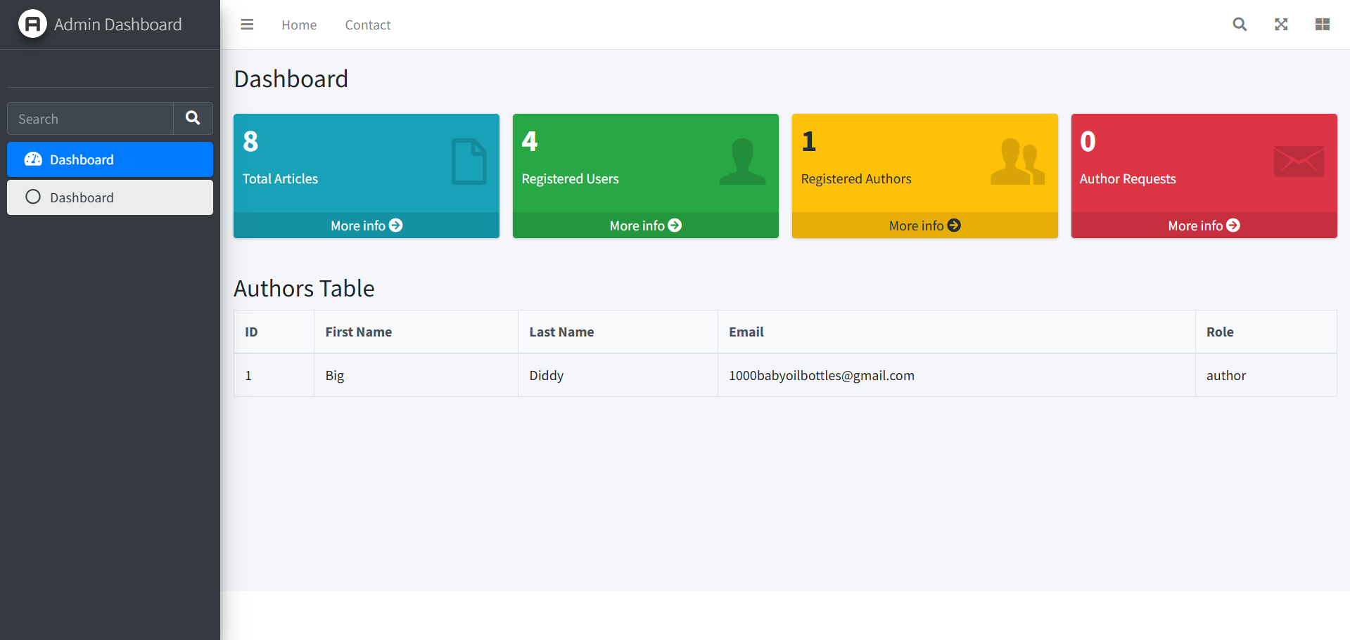

**PAGE UI ADMIN**

**AUTHOR REQUESTS**

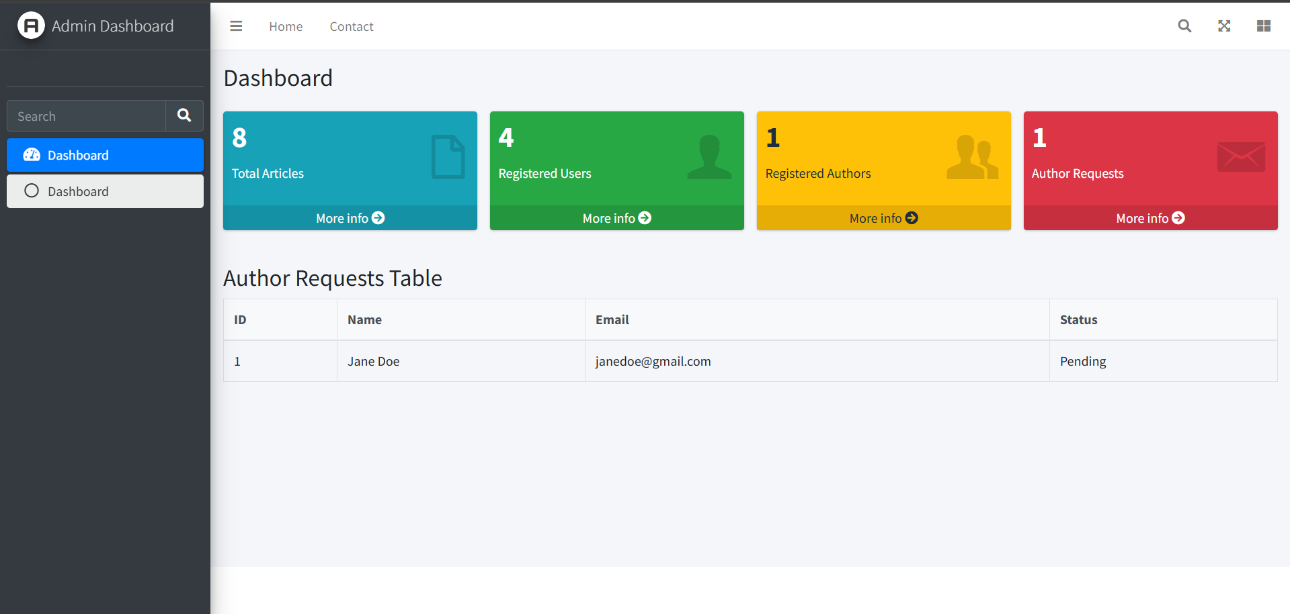

Hardware : Laptop - Lenovo Ideapad Gaming 3

Operating System : Windows 11

Software : Visual Studio Code IDE

Xampp

PhpMyAdmin

Git Bash

Microsoft Word

Microsoft Power Point

|  |  |  |
| --- | --- | --- |
| PROJECT FILE DETAILS | | |
| No. | File Name | Remarks |
| 1. | Gaming Article Website.docx | Microsoft Word file that contains project paper |
| 2. | Gaming Article Website.pdf | PDF file that contains project paper |
| 3. | Gaming Article Website Project 3.ppt | Microsoft Power Point file that contains presentation slide |
| 4. | gamingcornerdb.sql | Database Files |

**CONFIGURATION**